**Sunkari Manohar**

**Aditya Institute of Technology and Management**

**Assessment 3 - 06/12/23**

Today executed some Tcl commands, joins like inner, left outer join, right outer join and full outer join, constraints, keys.

**Having clause:**

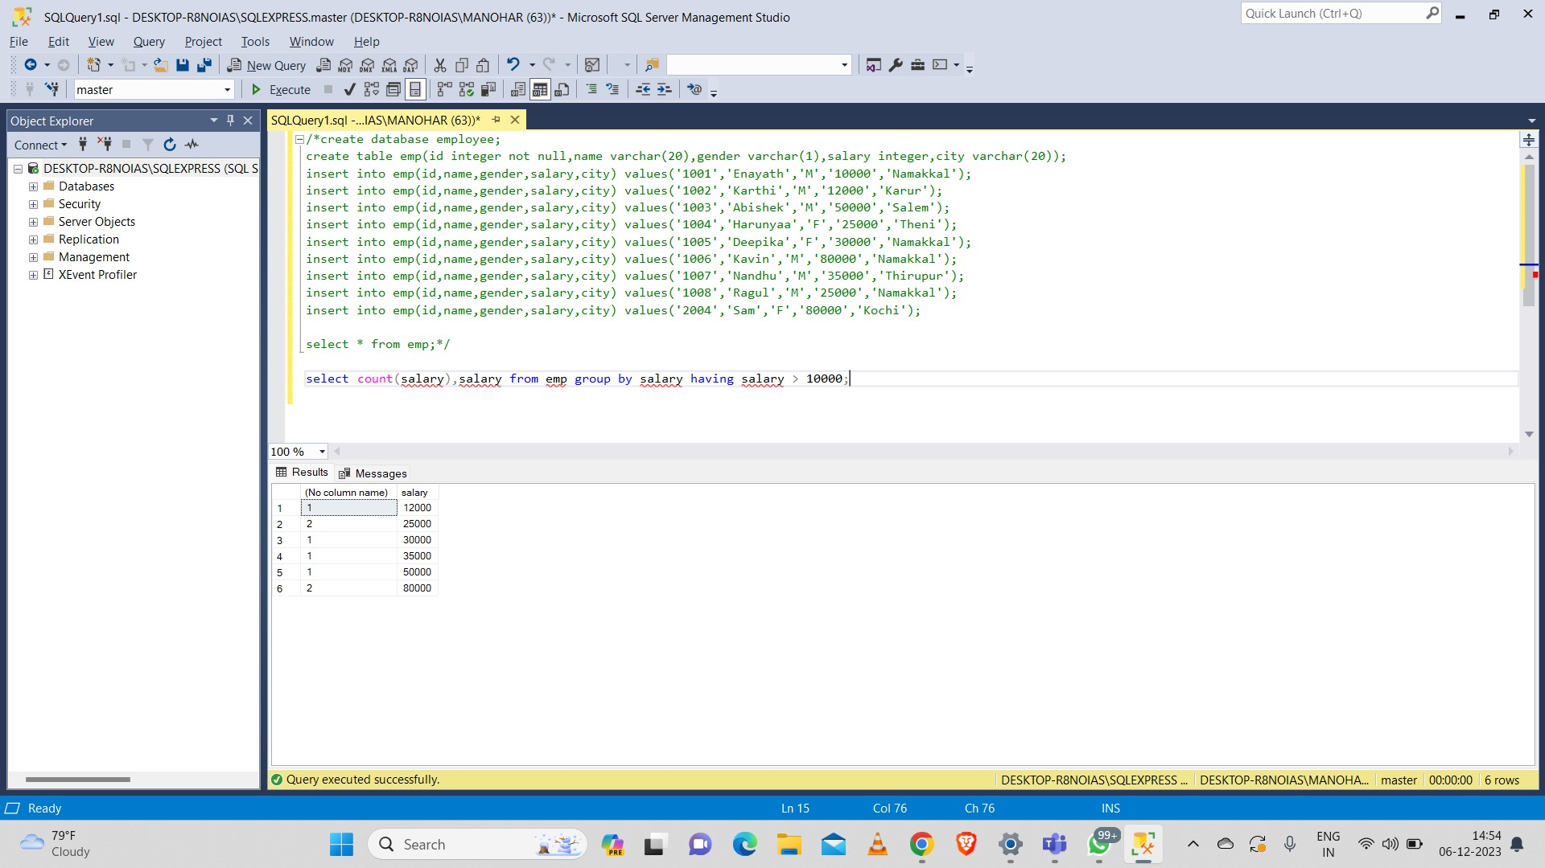

**GROUP BY Clause:**

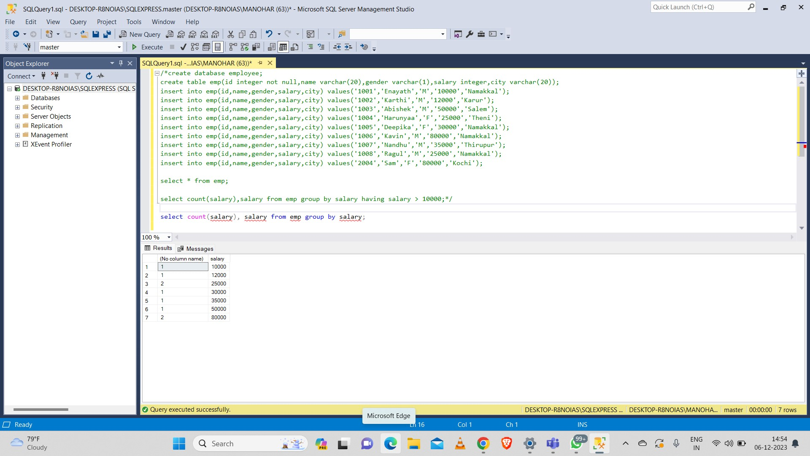

**Commit:**

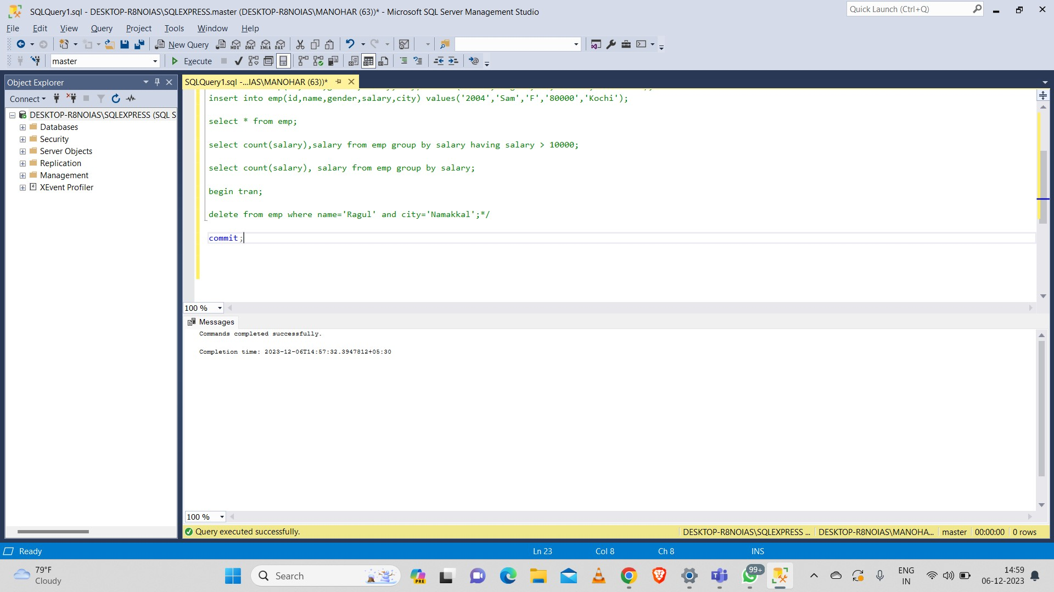

**Rollback:**

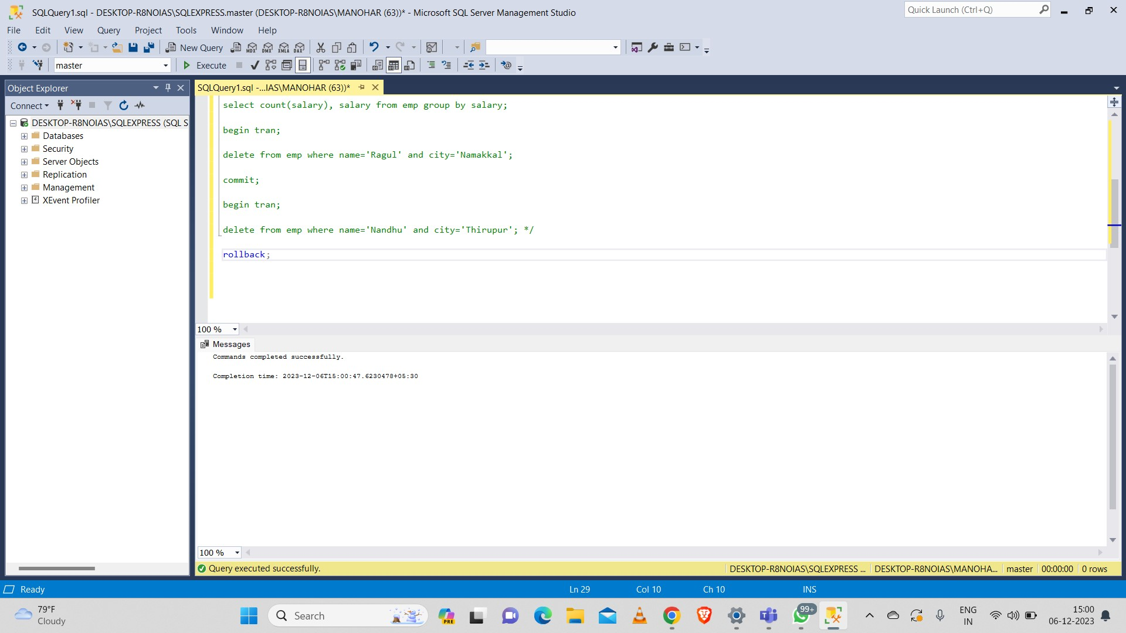

**Savepoint:**

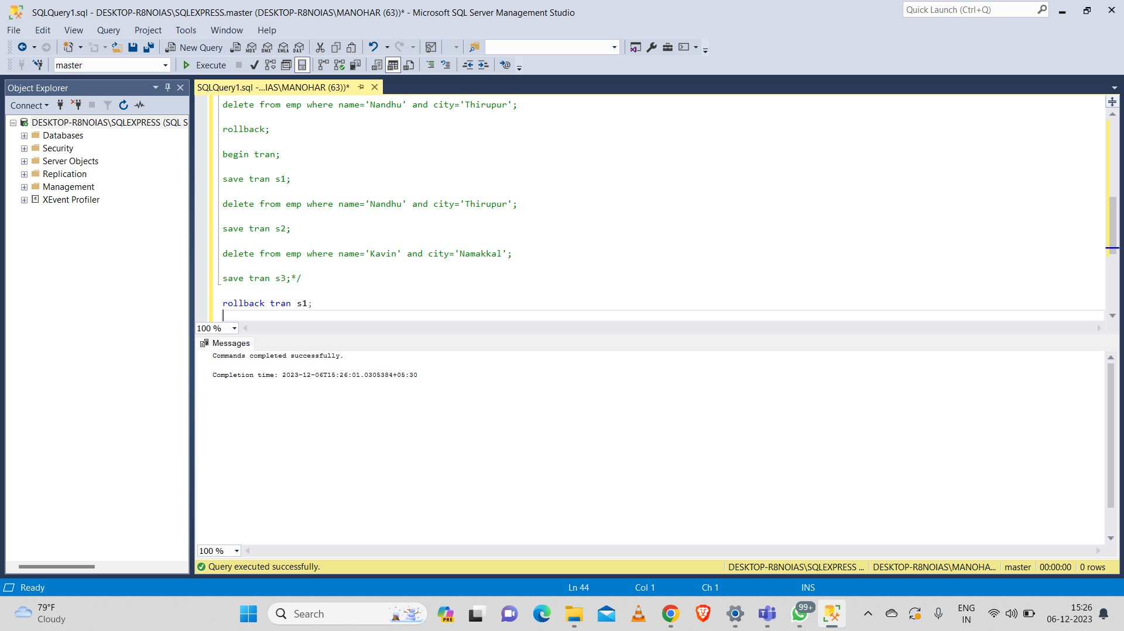

**Set operations:**

**Union operation:**

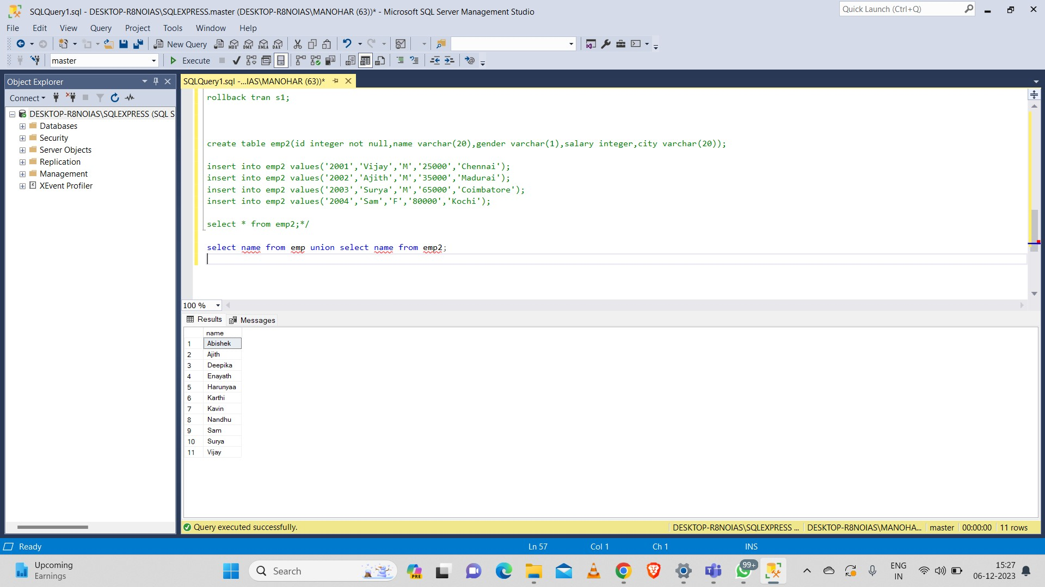

**To avoid duplicates we can use union all:**

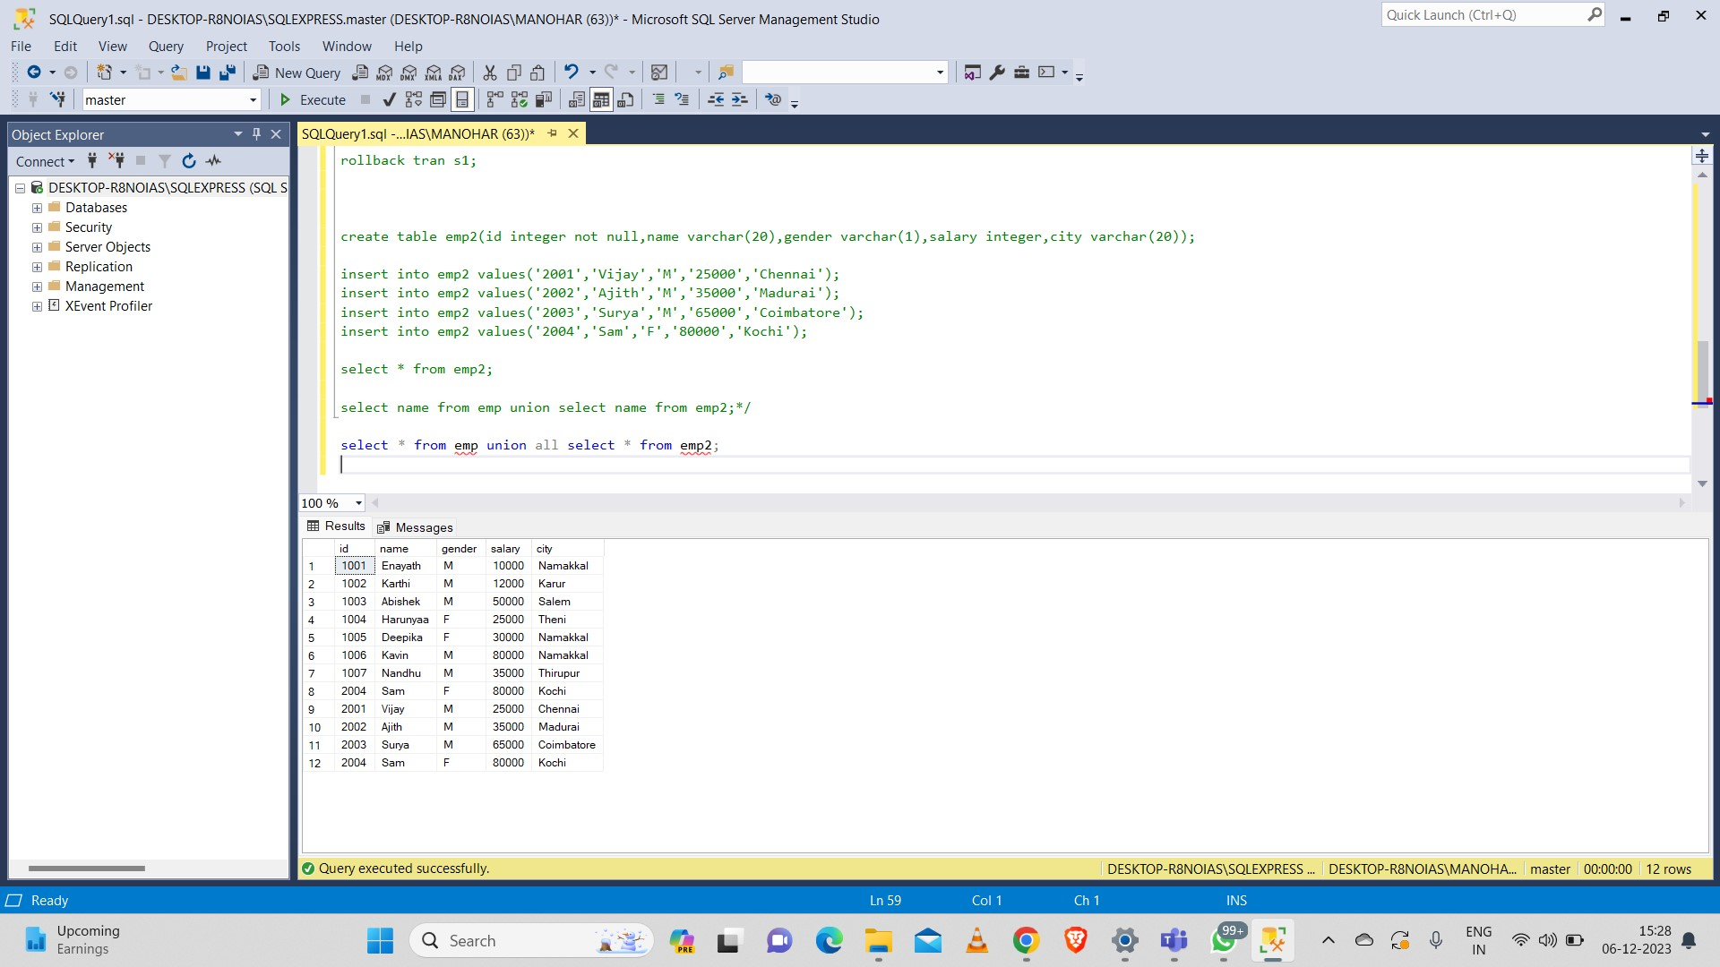

**intersect:**

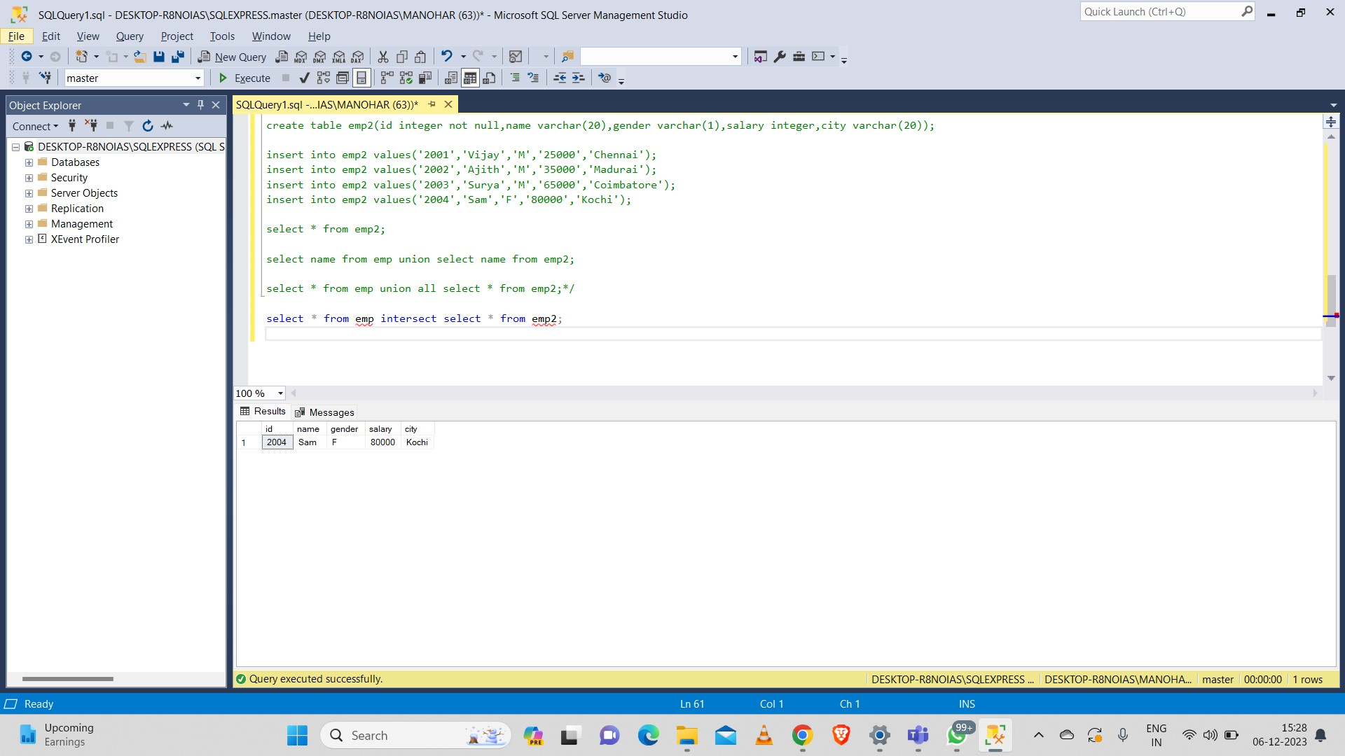

**except:**

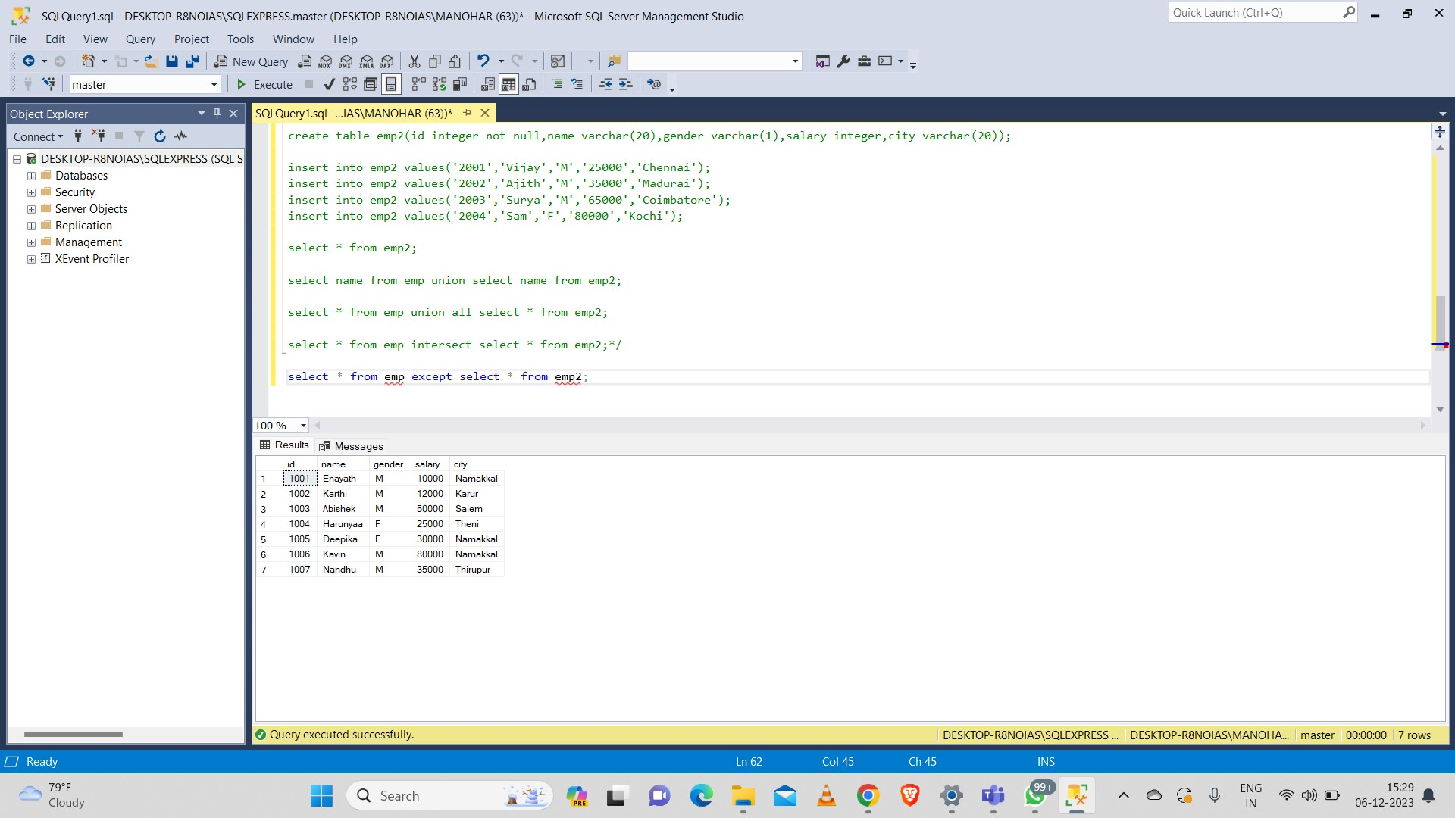

**Constraints:**

**Default:**

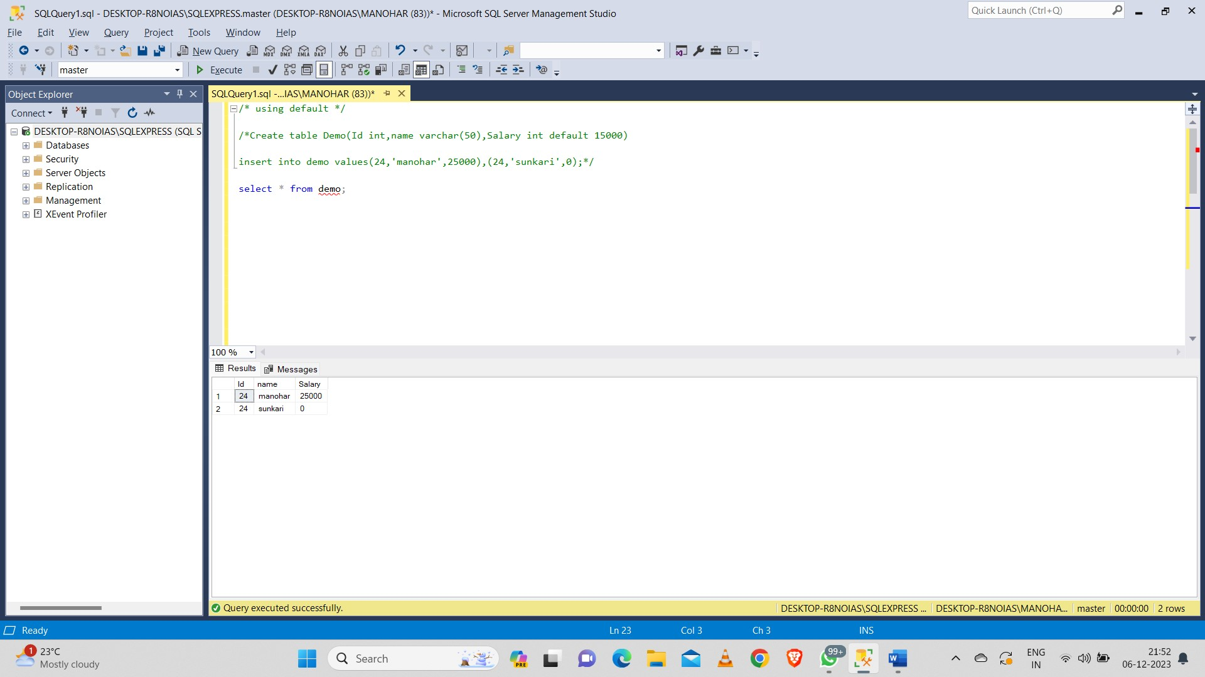

**Unique:**

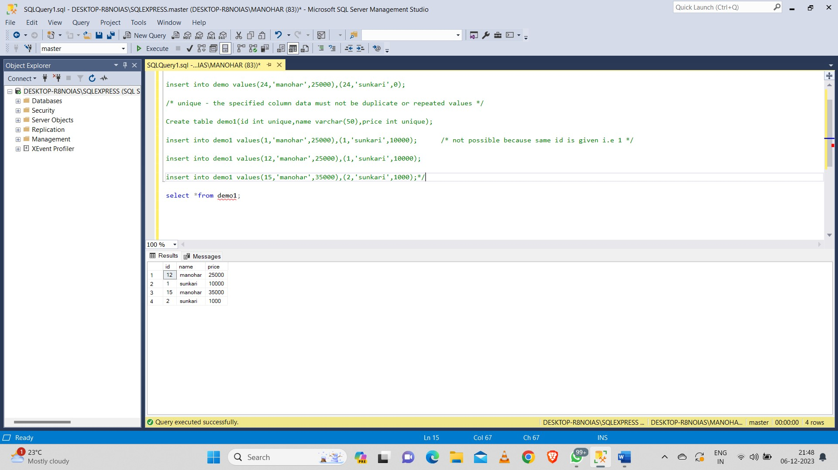

**Normalization:**

**Primary key:**

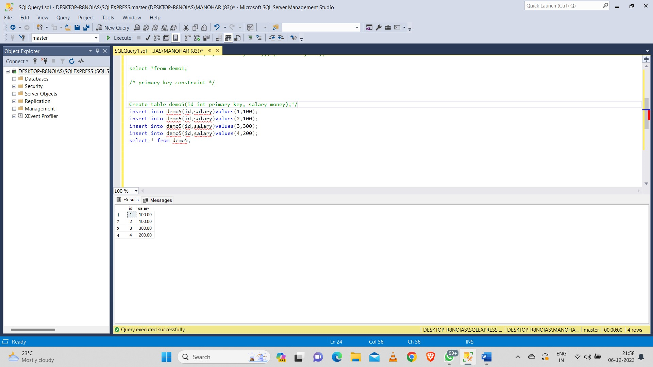

**Composite key:**

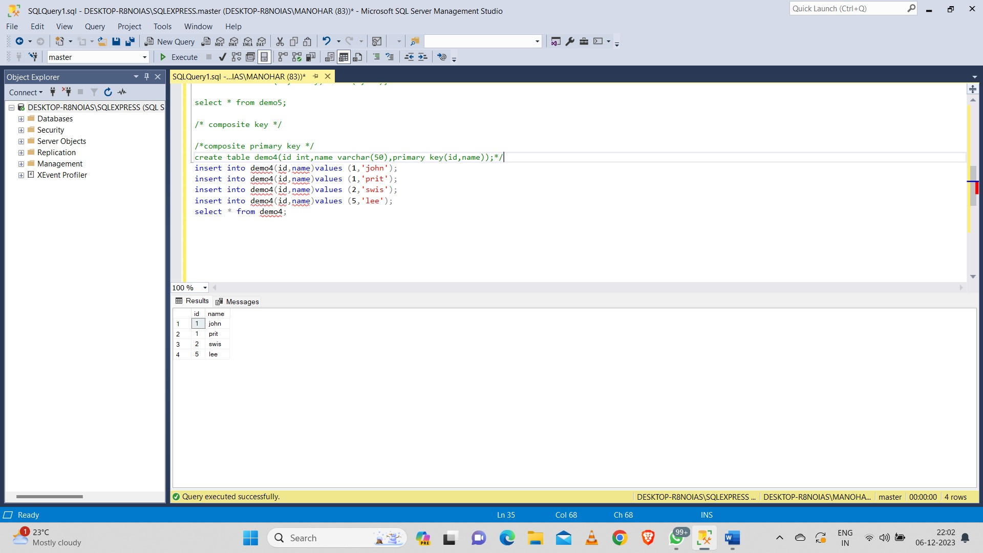

**Foreign key:**

